Bannari Amman Institute of Technology

Sathyamangalam -638 401,Erode District ,Tamil Nadu

DEPARTMENT OF COMPUTER SCIENCE AND ENGINEERING.

WEB PHISHING DETECTION

[(](C:\\Users\\mathe\\Downloads\\Assignment-2 Data Visualization and Data Preprocessing (1).pdf)**[ASSIGNMENT -2)](C:\\Users\\mathe\\Downloads\\Assignment-2 Data Visualization and Data Preprocessing (1).pdf)**

DATE : 28-09-2022

PROBLEM : TO ANSWER THE QUESTIONS FOR THE ANSWERS

NAME: VISHAL GUNA

**The [Dataset](https://drive.google.com/file/d/1_HcM0K8wt4b7FMLkc1V1dv0y6I_9ULzy/view) we have used Churn_modelling.csv**

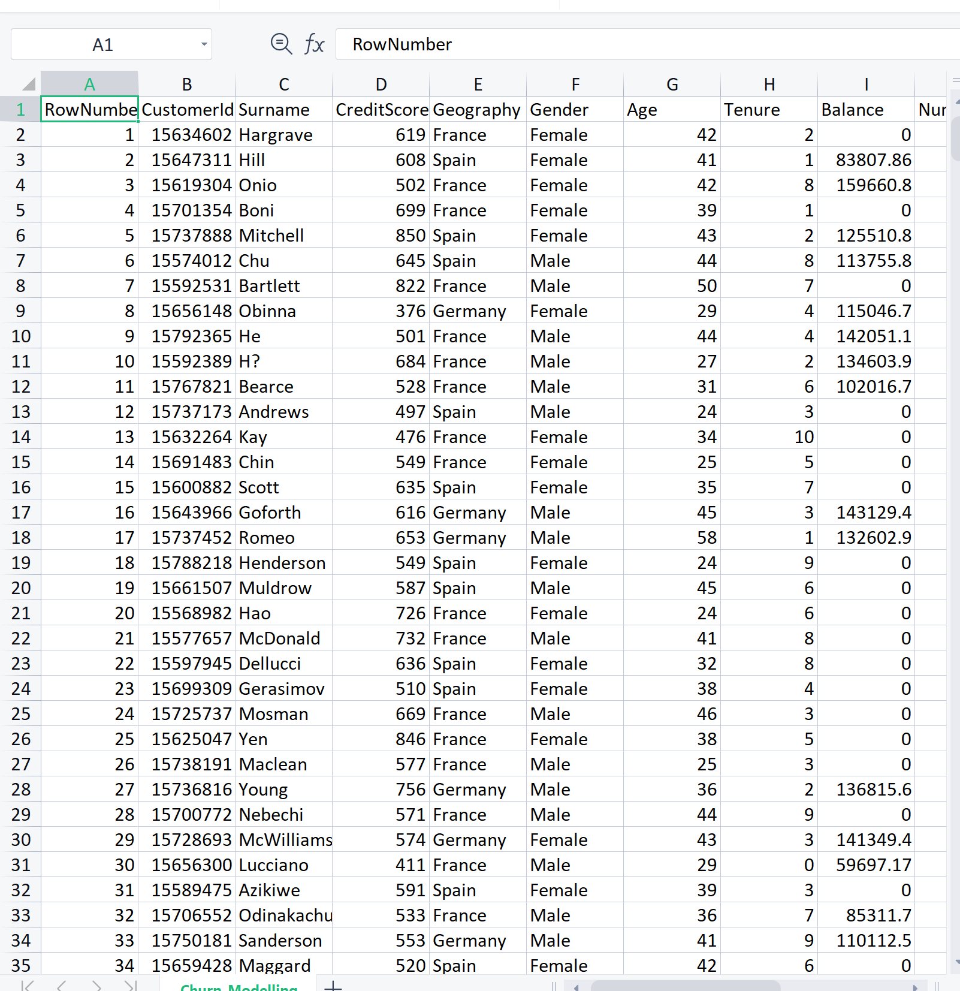

OUTPUT : SCREENSHOTS:

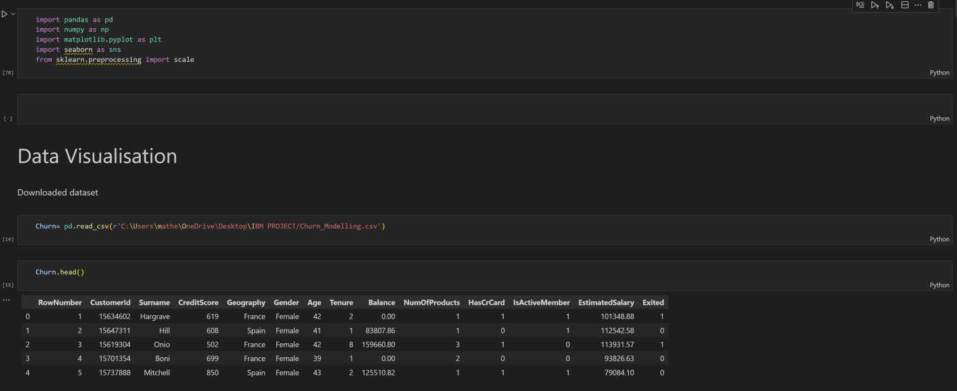

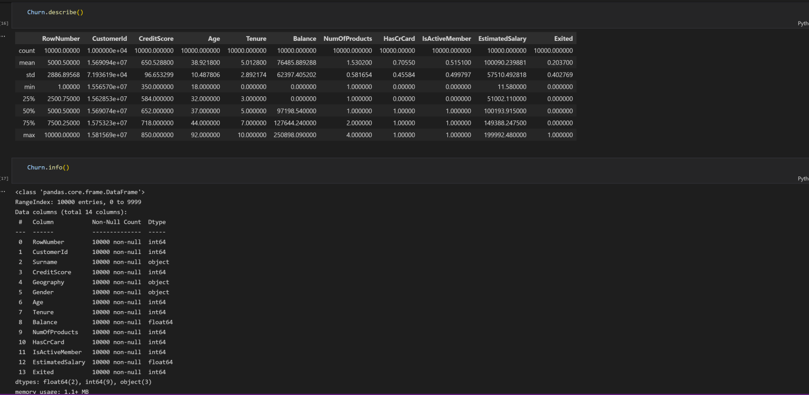

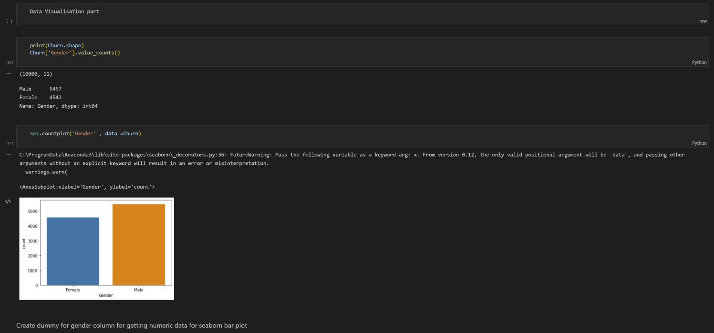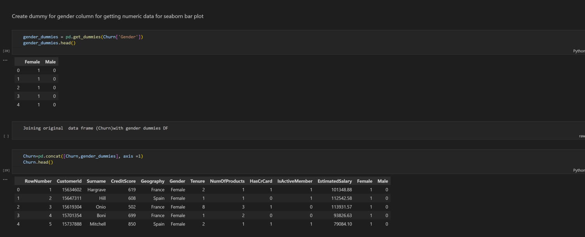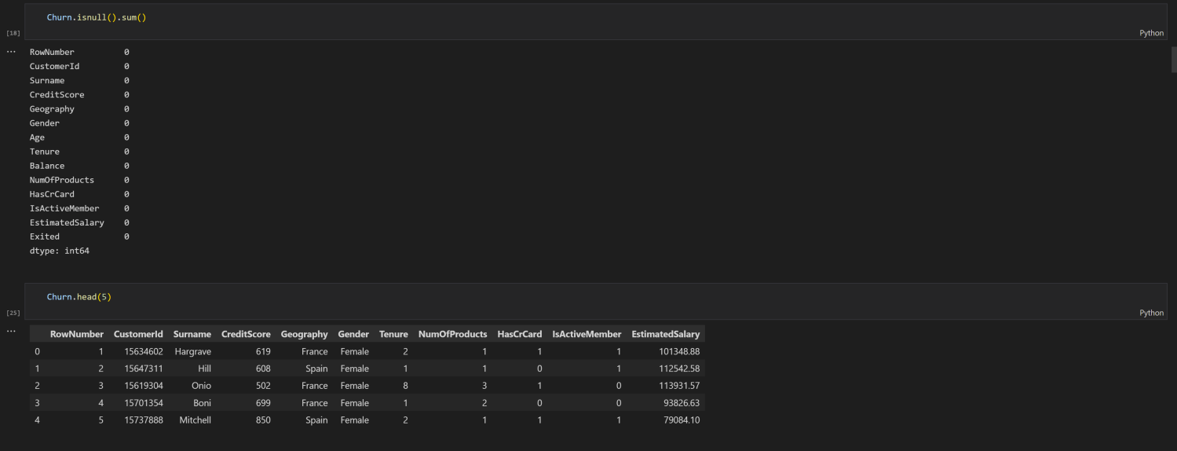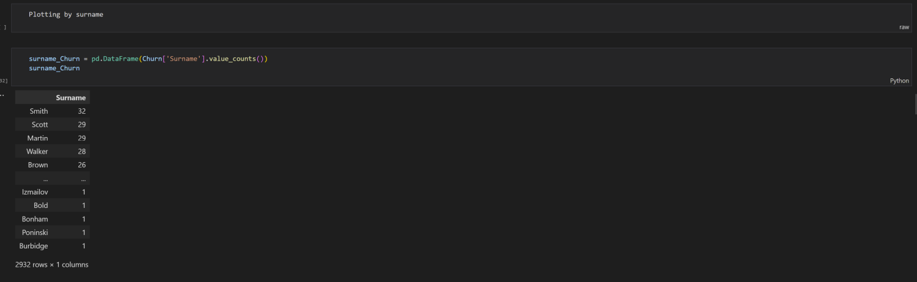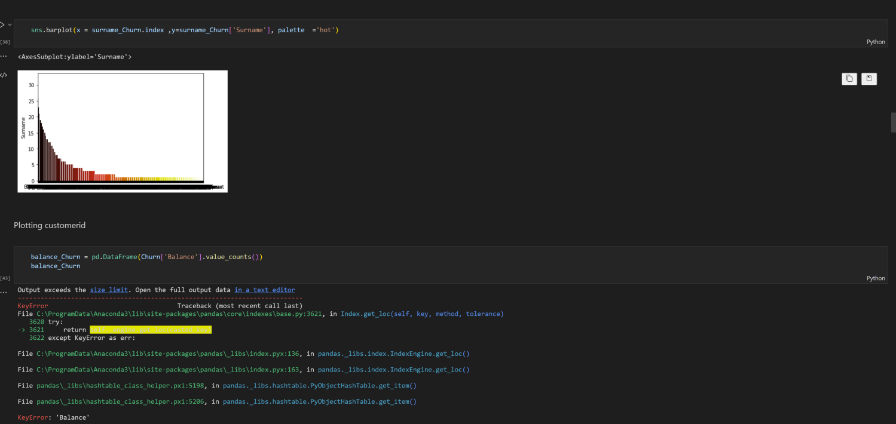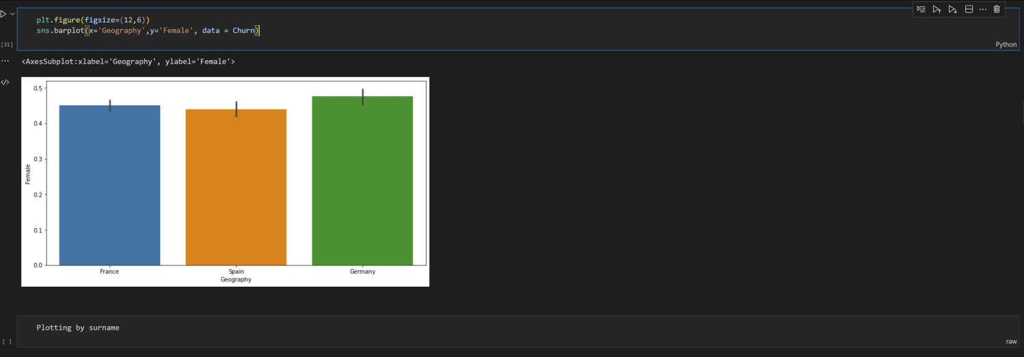

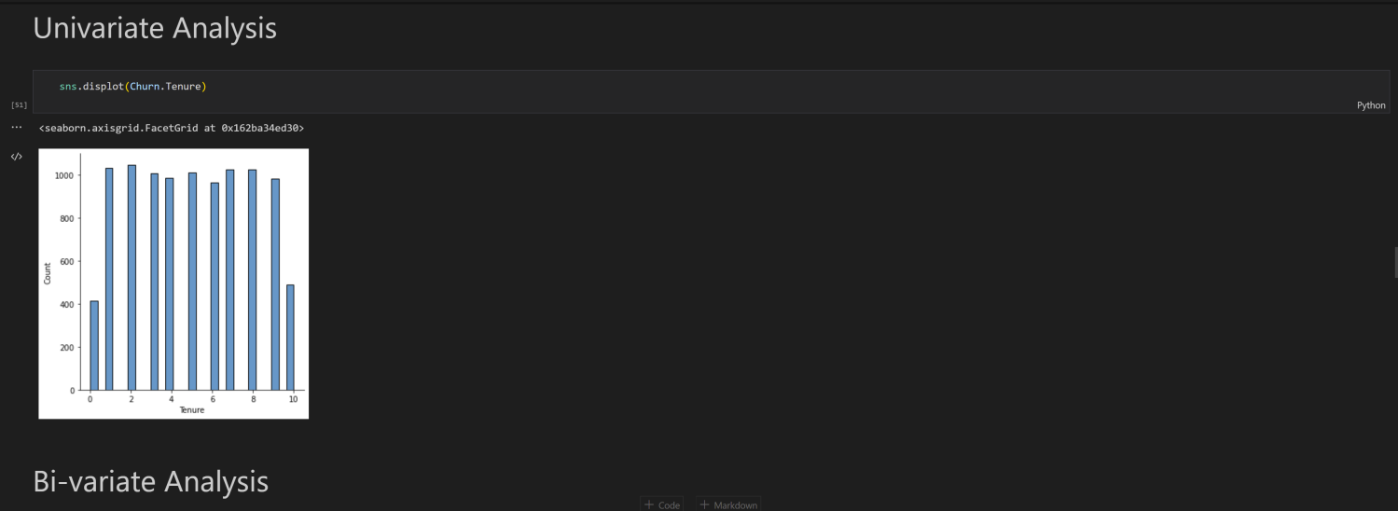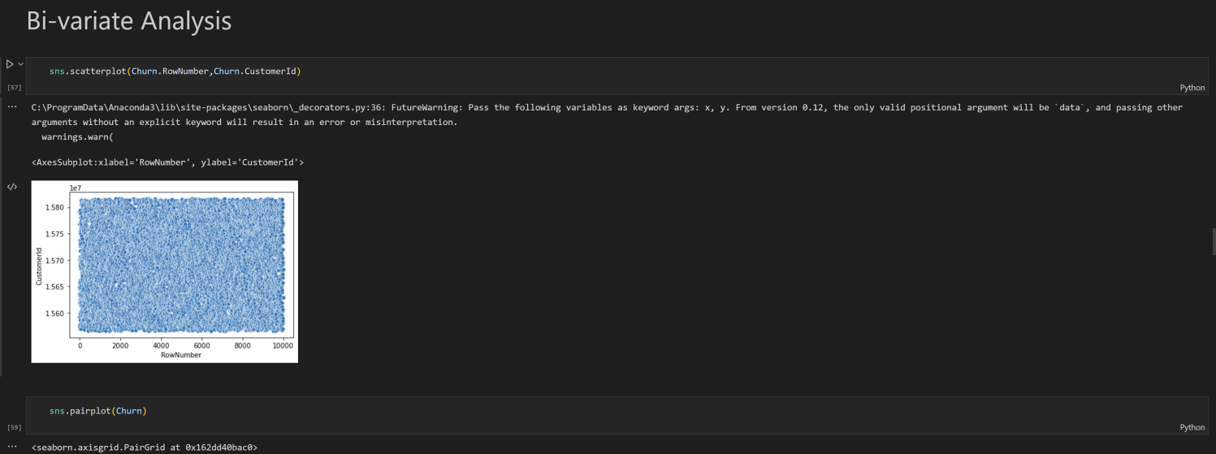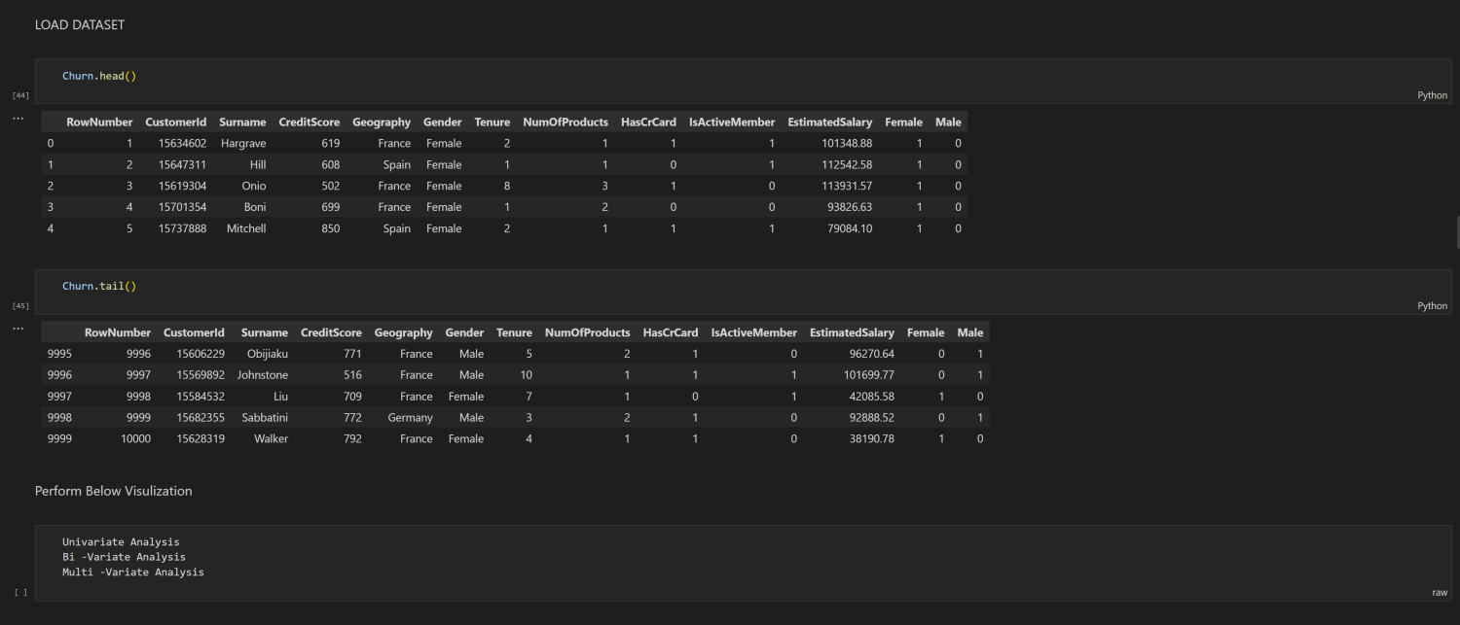

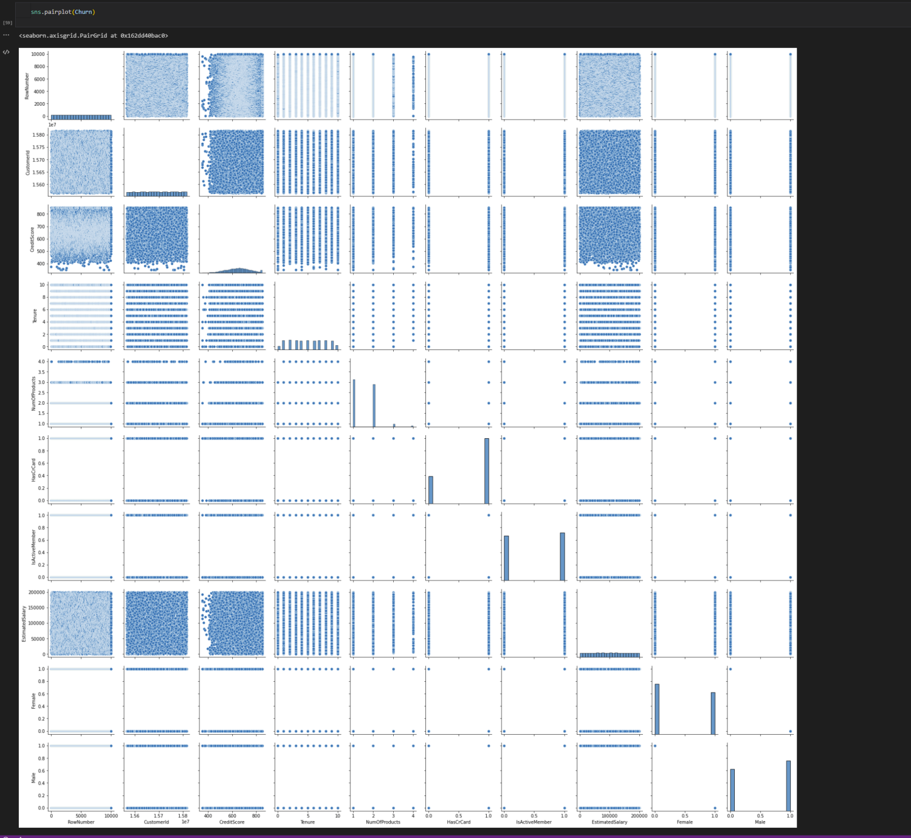

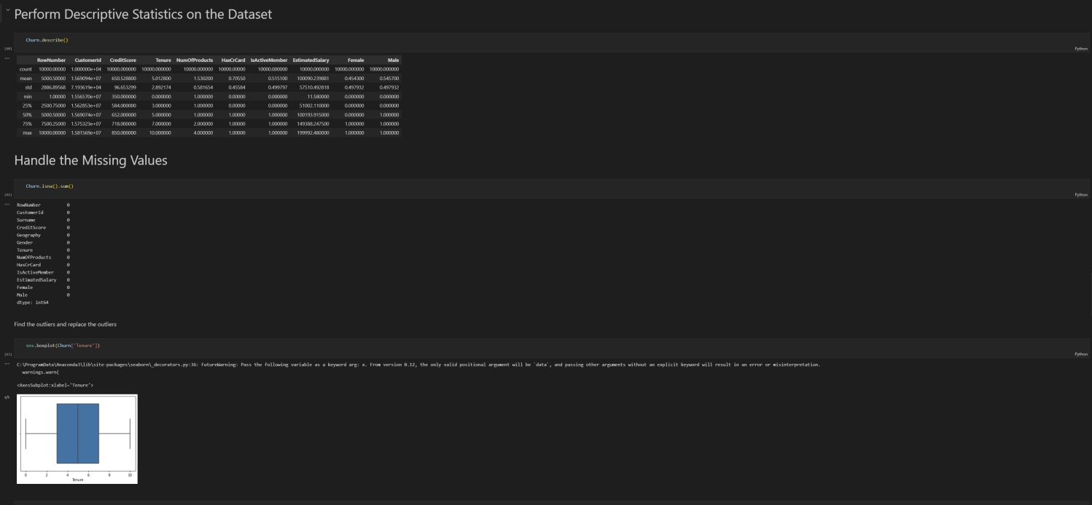

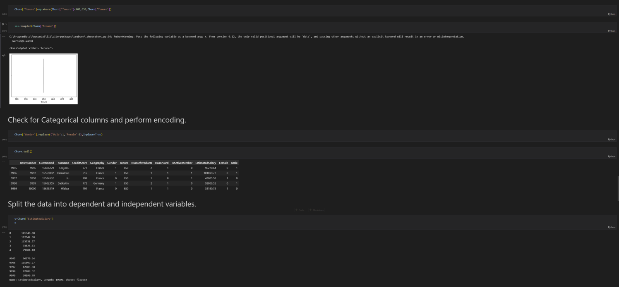

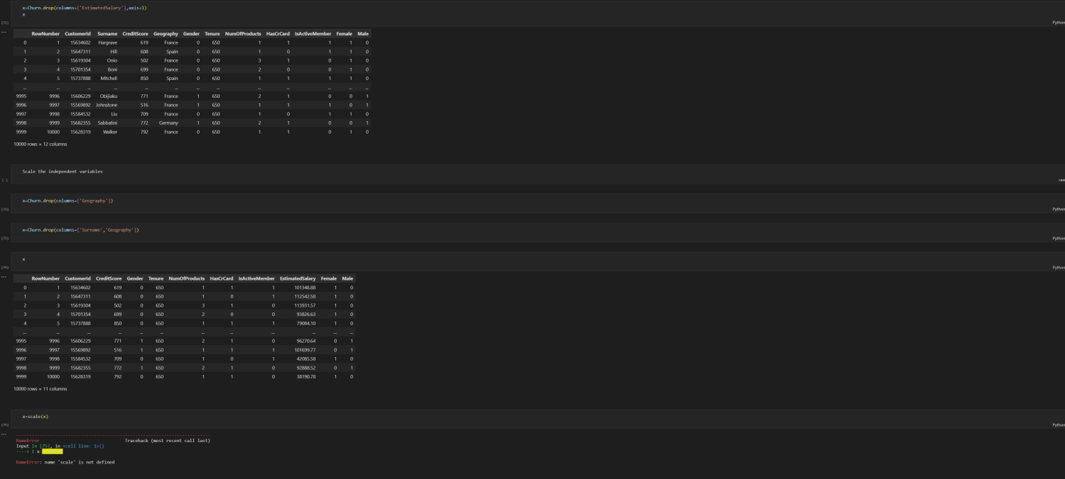

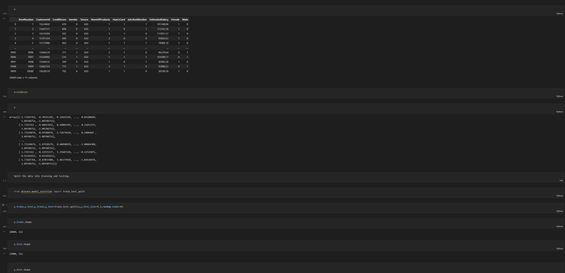

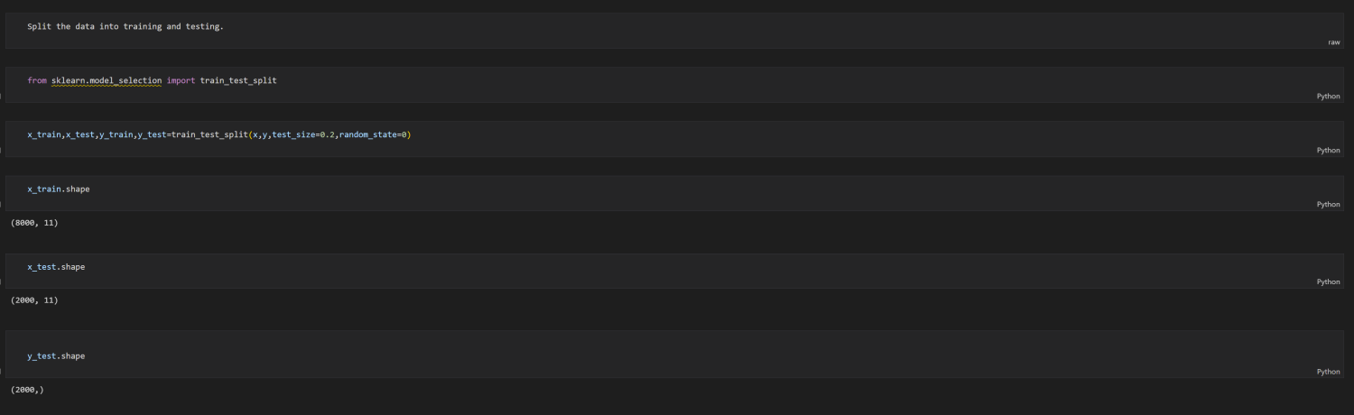

******************************THANKING YOU***********************************